Week 8 – SOFT7019 lab session

This week we will utilise an online C IDE called online gdb, please access it at <https://www.onlinegdb.com/>

In the top right corner, you will have the option to select the programming language, please select C.

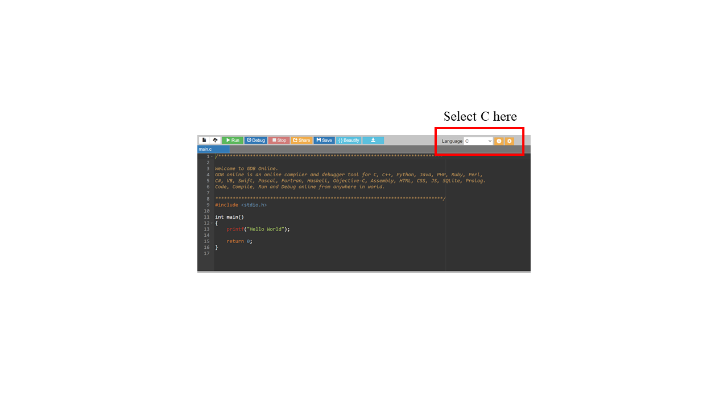

If you have a problem with this IDE, I would recommend installing CodeBlocks on your local machine. Last week we saw long lag times and errors ub the onlinegdb.com website during some of the lab sessions. I would recommend this guide to follow if installing CodeBlocks:

<https://www.youtube.com/watch?v=GWJqsmitR2I>

# Exercise 1

# **Student database**

1. Define a structure to hold a student’s name (max 10 chars) and the final grade (int).

struct student{

char name[10];

int grade;

};

1. Read the student’s name with scanf.

struct student s;

scanf("%s", s.name);

1. Write a function that sets the student final grade to a certain value

int change_grade(struct student *s, int new_grade){

if (s == NULL) return 1;

s->grade = new_grade;

return 0;

}

1. Print out the student’s name and final grade.

printf("%s --> %d\n", s.name, s.grade);

Put the above into a complete program.

# Exercise 2

**Counting vowels in text**

* read a line of text
* write a function that counts the number of occurrences of each letter
* the function should take as parameters

–the line of text; should be constant, to prevent modification within the function

–an array of 26 structs, representing the letters and their counts; this should be used as the output of the function

* at the end print the text read and for each vowel, the number of occurrences.

Hint

1. use a struct to store the ascii code for each letter and the count for that letter

struct letter_analysis{

char letter;

int count;

}

1. remember that the characters can be represented by their ascii values or their numeric values